**Analysis of World Bank Climate Change Indicators**

# Name: Muhammad Awais

# Student ID: 21084741

# Course: Applied Data Science 1

**Link repo :** [**https://github.com/awaismuhammad1234/ADS1-assignment02**](https://github.com/awaismuhammad1234/ADS1-assignment02)

# Introduction

Climate change is a pressing global issue that affects every nation on Earth. This report presents an analysis of selected climate change indicators for a group of countries and explores potential correlations between them. The main objective is to better understand the trends and relationships between these indicators and to provide a foundation for further analysis and policy recommendations.

# Dataset

To analyse the dataset, we employed the Python along libraries, including pandas, NumPy, Matplotlib, and Seaborn. I focused three key indicators: Population growth (annual %), CO2 emissions (metric tons per capita), and Energy use (kg of oil equivalent per capita). These indicators were chosen for their relevance to climate change and potential relationships with each other for countries United States, China, India, Germany, and Brazil, due to their diverse geographic locations, economic development levels, and global impact.

# Summary Statistics

The summary statistics showed interesting insights for the selected indicators and countries. Population growth (annual %) varied significantly among the countries, with minimum values ranging from -1.8% (Germany) to maximum 3.01% (Brazil). CO2 emissions (metric tons per capita) had a high variability across countries, with mean values ranging from 1.11 (India) to 18.51 (United States) and the United States had the highest standard deviation (1.74). Energy use (kg of oil equivalent per capita) also showed significant disparities among the countries, with mean values ranging from 384.69 (India) to 7421.26 (United States), and India had the lowest standard deviation (102).

This information can also be seen in the following graphs.

|  |  |
| --- | --- |
| C:\Users\autom\AppData\Local\Microsoft\Windows\INetCache\Content.MSO\8947A66B.tmp | C:\Users\autom\AppData\Local\Microsoft\Windows\INetCache\Content.MSO\649CB6B1.tmp |
| C:\Users\autom\AppData\Local\Microsoft\Windows\INetCache\Content.MSO\BEE0FE8D.tmp | C:\Users\autom\AppData\Local\Microsoft\Windows\INetCache\Content.MSO\BAA96F57.tmp |
|  | |

Also, I made regression plots to check the correlation between different indicators of countries. Those plots can be seen below.

From the following plot we can see that for some countries, such as USA and Germany, there seems to be a positive correlation between population growth and CO2 emissions. This indicates that as the population in these countries increases, CO2 emissions also tend to increase.Similar to the case of CO2 emissions, the relationship between population growth and energy use varies among countries. In the case of energy use, the regression line is inverted that shows the negative relationship between the population and energy usage per capita.

|  |  |
| --- | --- |
| C:\Users\autom\AppData\Local\Microsoft\Windows\INetCache\Content.MSO\37F41D23.tmp | C:\Users\autom\AppData\Local\Microsoft\Windows\INetCache\Content.MSO\2F613629.tmp |

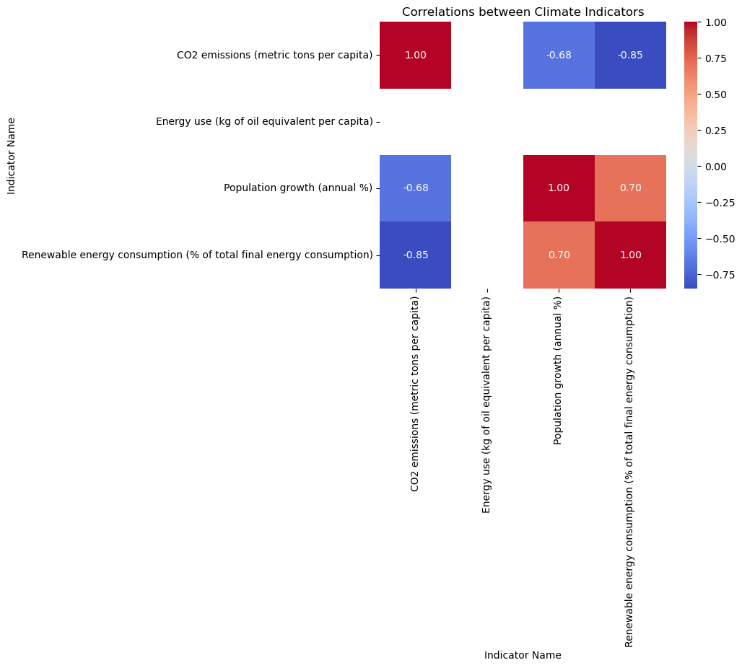

The plot highlights strong positive correlations between CO2 emissions per capita, energy use per capita, and GDP per capita, indicating that these variables tend to increase or decrease together. There is a moderate negative correlation between population growth and renewable energy consumption, suggesting that as population grows, the proportion of energy generated from renewable sources decreases.

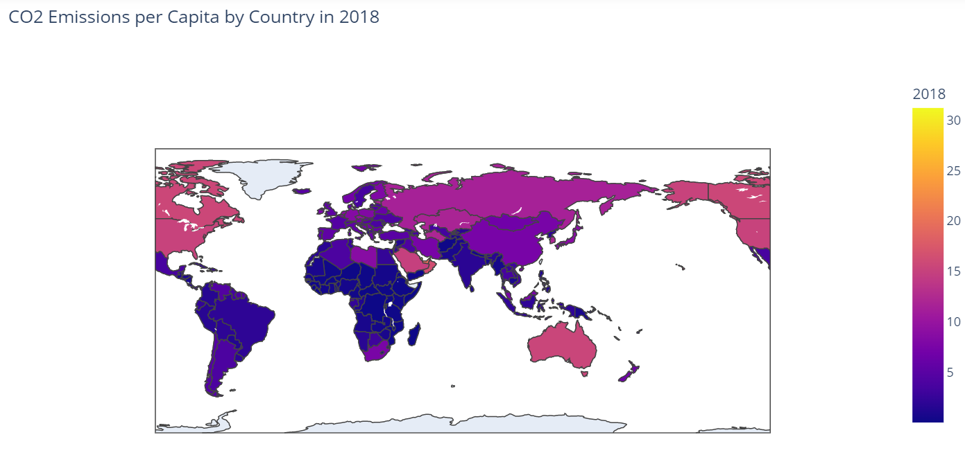

The choropleth plot shows the levels of CO2 emissions per capita for each country in 2018. The plot highlights the countries with the highest and lowest levels of CO2 emissions per capita. Countries with the highest emissions levels are primarily located in North America, Europe, and the Middle East, while countries with the lowest emissions levels are primarily located in Africa and some small island nations.

These observations suggest that the relationships between population growth, CO2 emissions, and energy use are complex and can vary significantly among countries. There is no universal trend, and understanding the factors driving these correlations requires a deeper analysis of each country's specific context and policies.